RECRUITMENT PACK

TRUSTEES

December 2022

Contents Page

Who we are, what we do 3

Our story 5

Current staff and Trustees 6

Role and responsibilities of Trustees 9

Application process 10

Attachments

* Rosie’s Trust Strategic Plan 2022 – 2025
* Trust Deed of Rosie’s Trust
* Code of Good Governance, 3rd Edition

Who we are and what we do

When someone is faced with a cancer diagnosis, disability or terminal illness, their whole world changes. They have so much to worry about, so much to deal with and the one thing they need - especially those living alone – is the emotional support that their companion pet provides.

They are no longer able to provide their dog or cat with the same level of care they once could and their anxiety about the welfare of their beloved companion only serves to compound their distress.

At the most stressful time of their lives, they may be forced to give up their companion pet and, in so doing, experience tremendous loss, isolation and feelings of guilt.

Some people have reported that they considered delaying or even refusing treatment because they had no one to look after their pet.

Rosie’s Trust is Northern Ireland’s only charity dedicated to helping the terminally ill, people undergoing cancer treatment, or older people with a disability hold on to their beloved pets. We care for our beneficiaries’ companion dogs and/or cats in their homes when they are no longer able to look after them independently.

Subject always to our beneficiaries’ wishes, we can provide fostering services when they need to spend a period of time in hospital or in hospice care. We can also find new homes for their pets when the beneficiaries are no longer able to care for them, including when they die.

Rosie’s Trust also offers a pet bereavement service, providing emotional support to beneficiaries when their companion pet predeceases them.

We provide our services free of charge, 365 days of the year. We depend on donations to cover our service costs, and every penny gifted to us is carefully used.

Our services offer peace of mind for our beneficiaries as they know Rosie’s Trust will support them in the care of their companion pet for as long as they need us and our resources permit.

Rosie’s Trust services not only help to address loneliness and social exclusion in Northern Ireland, but also to promote animal welfare, in accordance with the Welfare of Animals Act (NI) 2011.

**Extensive network of volunteers**Our full-time staff of three are supported by a team of 140+ committed volunteers who are the lifeforce of Rosie’s Trust. They provide help and support in all aspects of pet care, including feeding, grooming, exercising, play and stimulation, and vet visits. Our volunteers are our eyes and ears, ensuring when they visit that our beneficiaries are as well as can be and providing welcome social contact for many. Our volunteers work in teams, with each member making two visits a week.

Our volunteers receive intense training before being matched to a beneficiary. This ensures they all have a sound understanding Rosie’s Trust’s policies and procedures to promote the health and wellbeing of our beneficiaries, their pets and the volunteers themselves. They are also trained to signpost to partner organisations, wherever necessary.

Since our establishment in 2015, we have served 180+ beneficiaries. Currently we serve 40 beneficiaries, located in four of the five Health and Social Care Trusts (Belfast, Northern, Southern and South Eastern). We aim to provide services in the Western Health and Social Care Trust area by late 2022.

We were advised in October 2022 that our application to the Dormant Accounts Fund for £100,000 was successful. These funds will be used over two years to engage experienced Fundraising and Communications and Engagement professionals to future proof Rosie’s Trust and help achieve the objectives of our Strategic Plan 2022-2025 (attached).

**Our Values**

#Compassion #Integrity #Inclusiveness #Respect #Quality #Partnership #Confidentiality

Our story  
  
The original idea for Rosie’s Trust was born in 2015 when our founder, Bronagh O’Neill (pictured here with her dog, Rosie), who was a nurse at the time, learned first-hand from a friend of hers the impact that cancer had had on his ability to look after his beloved dog. He lived alone and described how he could no longer care for his “very special friend”.

Through subsequent research and discussions with organisations such as Marie Curie, Macmillan Cancer Support, Age NI and local Health and Social Care Trusts, Bronagh also learned that large numbers of people were having to surrender their pets at a time when they needed them most because they were too weak to care properly for them themselves.

Bronagh’s findings demonstrated to her the pressing need for a charity such as Rosie’s Trust in Northern Ireland.   Since its establishment, Rosie’s Trust has worked with an increasing number of individuals and organisations (statutory, corporate as well as community and voluntary sector) to ensure we are continuing to provide the care and support that is required.

The Trust Deed setting out the objects of Rosie’s Trust is attached.

Current staff and Trustees

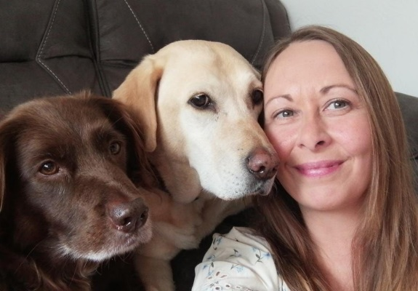  
Jayne McStay Laura Quinn Sandra McFadden  
Operations Manager Development Officer Volunteer Support Officer

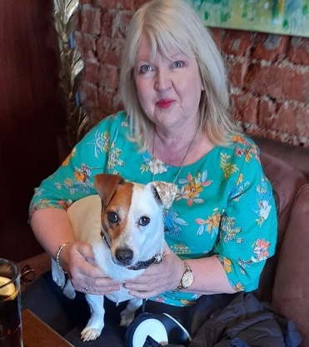**Joyce Savage, Acting Chair**

I joined the Board of Rosie’s Trust in September 2021. I have worked in the voluntary sector for more than 25 years in a range of charities of different sizes and levels of development. This has given me a good understanding of what works for a successful charity – and what doesn’t. Aside from charity management experience my expertise covers the areas of income generation, communications, campaigning and public affairs.

As a dog owner and someone living alone, I understand the concerns for a pet’s welfare when life isn’t going as it should or as was planned. I hope to bring my practical experience and personal motivation together to help Rosie’s Trust continue to grow and develop and to be there for all the 4- and 2-legged beneficiaries needing our support.

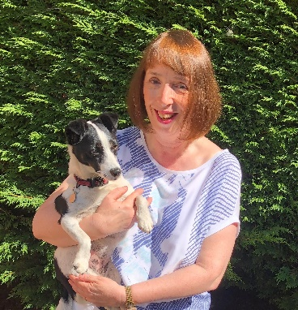**Fiona Coulter**

I joined Rosie’s Trust in June 2017 as a Canine Support Volunteer after seeing an article in the paper about Bronagh O’Neill and the charity she had set up. Following various lockdowns, I decided that I wanted a new challenge but was very keen to stay involved with the charity so I joined the Board of Trustees in September 2021.

Since joining Rosie’s Trust as a volunteer, I have seen first-hand the importance of the work of the charity. Through our involvement, pets can remain with their owners at the darkest of times. Often their pets are the only company that the beneficiary has and it’s heart-warming to see the love they have for their pets and how much they value the help volunteers provide. Without Rosie’s Trust, many of our beneficiaries would have had to give up their beloved pets and would be totally on their own. Definitely enough reason to volunteer with Rosie’s Trust!

**Diane James**I have worked with Rosie’s Trust in an external capacity for a few years. I met Bronagh (the founder) through my job as ‘Head of Pet Loss and Bereavement’ for Blue Cross animal charity. I became a Trustee about a year ago and I also work with Rosie’s Trust’s pet bereavement team.

Once I had met the team and saw the amazing work they do, I knew I wanted to do what I could to support such a fantastic initiative. Every single person I have talked to and worked with is very special; they all have the same passion to make Rosie’s Trust the best it can be. I am very thankful to be part of it.

**Tim Leonard**

I have been a Trustee with Rosie’s Trust for the last seven years. It has been a joy to see the charity develop from the beginning, though the vision and efforts of Bronagh O’Neill to the current time under our wonderful operations team. It is great to see the impact of the charity in preserving the bond between our beneficiaries and their pets. I have found my time with Rosie’s Trust very rewarding and look forward to the growth of the charity over time to reach more people and pets in need.

**Josephine Mallon**

I became a Trustee in January 2021. I have always shared my life with furry friends and have experienced the sheer joy of canine friendship, being both the giver and receiver of unconditional love. I was drawn to Rosie’s Trust because I wanted to be part of a team of liked-minded people, who wish to maintain the unique bond between owner and beloved pet. Wet noses, waggy tails and sloppy kisses make our hearts since and lift our spirits. I am privileged and humbled to work in a charitable organisation with such dedicated staff and volunteers who work tirelessly to support our most vulnerable.

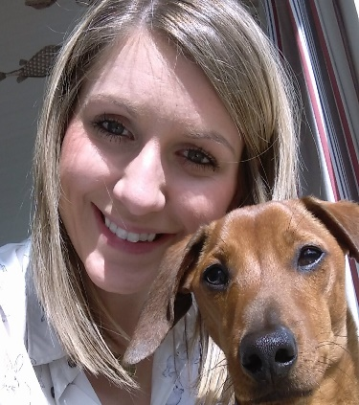**Joy McGimpsey**I have been a Trustee with Rosie’s Trust since September 2021. I got involved as I believe that what Rosie’s Trust do is unique, inspiring and extremely valuable to the community. I was drawn to the dual aspect of supporting vulnerable people as well as benefitting their pets. A pet is part of the family and to work with an organisation that recognises and champions pets while removing the stresses and anxieties of their owners at what can be difficult times is extremely rewarding.

**Emer Rice**

I have been a Trustee since January 2021. As an animal lover I really wanted to get involved with Rosie’s Trust as I understand how important our pets are to us, never more so than when we are going through difficult times in life.  
To play a small part in helping to maintain that bond between someone and their little companion is so rewarding.

**Note:** All Trustee positions are voluntary at Rosie’s Trust. Typically, the term of office is for three years with the possibility of further extension.

Role and responsibilities of Trustees

Trustees ensure their charity has a clear strategy, and that its work and goals are in line with its vision. A trustee's role in a charity is to be the ‘guardians of purpose’, making sure that all decisions put the needs of the beneficiaries first.

They safeguard the charity’s assets – both physical assets, including property, and intangible ones, such as its reputation. They make sure these are used well and that the charity is run sustainably.

Trustees don’t usually do the day-to-day running of the charity. They delegate this to the staff, led by the Chief Executive. Instead, they play the role of a ‘critical friend’ to the Chief Executive by giving support and by challenging – in a supportive way – to help them manage effectively. However, in smaller charities with few staff, Trustees may take hands-on roles too.1

Good governance is about putting in place the right policies, procedures and checks to help a charity achieve its objects, enabling it to clearly demonstrate the good outcomes it has achieved for its beneficiaries, its staff and volunteers, and the community.

Trustees come from all walks of life, and bring with them their own skills, knowledge and experience. However, no matter their age or background, all trustees need the practical help required to develop high standards of governance and improve practice. Rosie’s Trust is guided at all times by the *Code of Good Governance*, developed by the Charity Commission for Northern Ireland. A copy of the Code is attached for ease of reference.

1. The essential trustee: what you need to know, what you need to do. May 2018. The Charity Commission.

Application Process

If you would like to join the Board of Trustees of Rosie’s Trust, please send your CV together with a cover letter outlining the reasons for your interest in the position and the skills and experience that you would bring to Rosie’s Trust.

Please send this documentation to [catriona@rosiestrust.org](mailto:catriona@rosiestrust.org) by   
**5.00pm,Tuesday 24 January, 2023.**