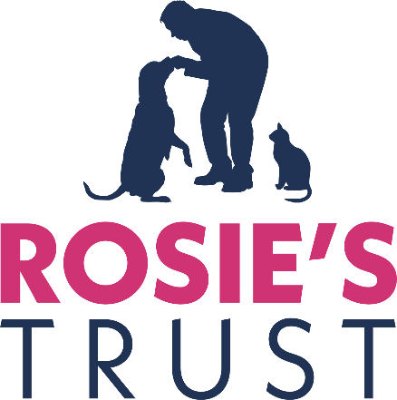

RECRUITMENT PACK
CHAIR, BOARD OF TRUSTEES

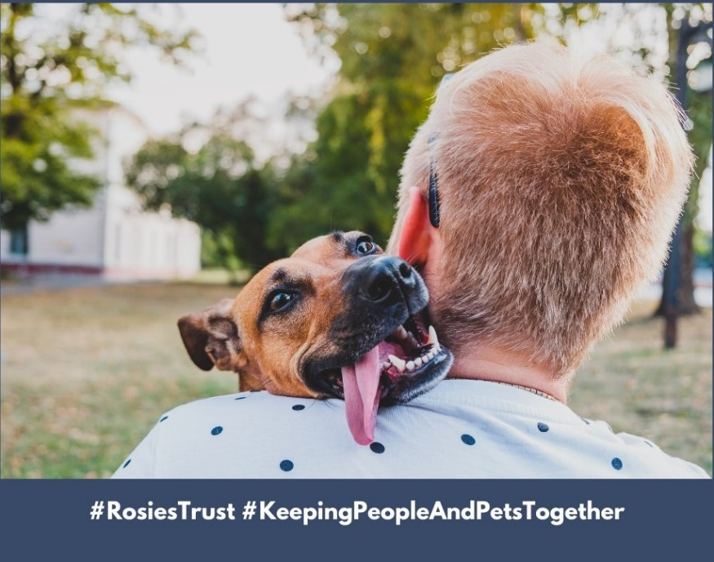

May 2023

Contents Page

Who we are, what we do 3
Our story 5
Current staff and Trustees 6
Organisation Chart 8
Role and responsibilities of the Chair of the Board of Trustees 9
Application process 11

Who we are and what we do
When someone is faced with a cancer diagnosis, disability or terminal illness, their whole world changes. They have so much to worry about, so much to deal with and the one thing they need - especially those living alone – is the emotional support that their companion pet provides.

They are no longer able to provide their dog or cat with the same level of care they once could and their anxiety about the welfare of their beloved companion only serves to compound their distress.

At the most stressful time of their lives, they may be forced to give up their companion pet and, in so doing, experience tremendous loss, isolation and feelings of guilt.

Some people have reported that they considered delaying or even refusing treatment because they had no one to look after their pet.

Rosie’s Trust is Northern Ireland’s only charity dedicated to helping the terminally ill, people undergoing cancer treatment, or older people with a disability hold on to their beloved pets. We care for our beneficiaries’ companion dogs and/or cats in their homes when they are no longer able to look after them independently.

Subject always to our beneficiaries’ wishes, we can provide fostering services when they need to spend a period of time in hospital or in hospice care. We can also find new homes for their pets when the beneficiaries are no longer able to care for them, including when they die.

Rosie’s Trust also offers a pet bereavement service, providing emotional support to beneficiaries when their companion pet predeceases them.

We provide our services free of charge, 365 days of the year. We depend on donations to cover our service costs, and every penny gifted to us is carefully used.
Our services offer peace of mind for our beneficiaries as they know Rosie’s Trust will support them in the care of their companion pet for as long as they need us and our resources permit.
Rosie’s Trust services not only help to address loneliness and social exclusion in Northern Ireland, but also to promote animal welfare, in accordance with the Welfare of Animals Act (NI) 2011.
Extensive network of volunteers
Our full-time staff of three are supported by a team of 150+ committed volunteers who are the lifeforce of Rosie’s Trust. They provide help and support in all aspects of pet care, including feeding, grooming, exercising, play and stimulation, and vet visits. Our volunteers are our eyes and ears, ensuring when they visit that our beneficiaries are as well as can be and providing welcome social contact for many. Our volunteers work in teams, with each member making two visits a week.

Our volunteers receive intense training before being matched to a beneficiary. This ensures they all have a sound understanding Rosie’s Trust’s policies and procedures to promote the health and wellbeing of our beneficiaries, their pets and the volunteers themselves. They are also trained to signpost to partner organisations, wherever necessary.

Since our establishment in 2015, we have served 180+ beneficiaries. Currently we serve 40 beneficiaries, located in four of the five Health and Social Care Trusts (Belfast, Northern, Southern and South Eastern).
We made a successful application to the Dormant Accounts Fund for £100,000 in late 2022. These funds are being used over two years to engage experienced Fundraising and Communications and Engagement professionals to future proof Rosie’s Trust and help achieve the objectives of our Strategic Plan 2022-2025 (attached).
We also received a three-year grant (People and Communities) from the National Lottery Community Fund in April 2023.
Our Values
#Compassion #Integrity #Inclusiveness #Respect #Quality #Partnership #Confidentiality

Our story
The original idea for Rosie’s Trust was born in 2015 when our founder, Bronagh O’Neill (pictured here with her dog, Rosie), who was a nurse at the time, learned first-hand from a friend of hers the impact that cancer had had on his ability to look after his beloved dog. He lived alone and described how he could no longer care for his “very special friend”.
Through subsequent research and discussions with organisations such as Marie Curie, Macmillan Cancer Support, Age NI and local Health and Social Care Trusts, Bronagh also learned that large numbers of people were having to surrender their pets at a time when they needed them most because they were too weak to care properly for them themselves.
Bronagh’s findings demonstrated to her the pressing need for a charity such as Rosie’s Trust in Northern Ireland. Since its establishment, Rosie’s Trust has worked with an increasing number of individuals and organisations (statutory, corporate as well as community and voluntary sector) to ensure we are continuing to provide the care and support that is required.

Current staff and Trustees

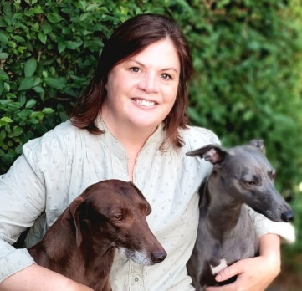 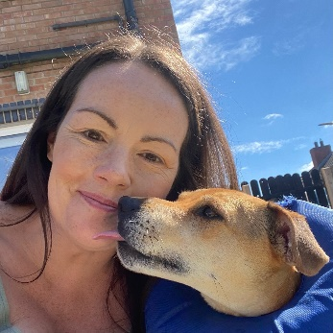 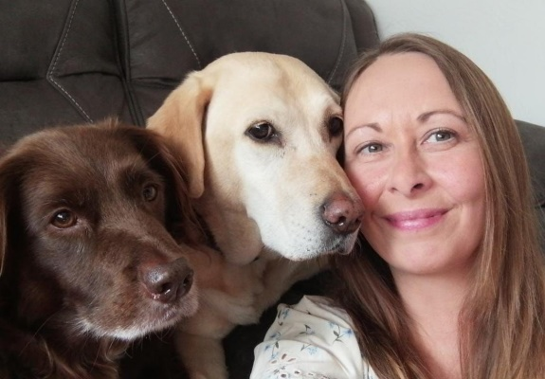
Jayne McStay Laura Quinn Sandra McFadden
Operations Manager Development Officer Volunteer Support Officer

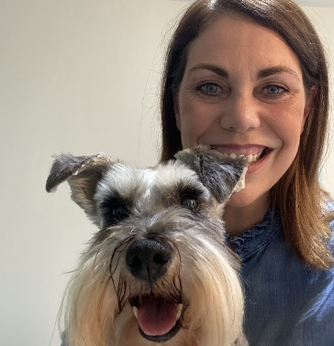
Josephine Mallon, Acting Chair
I became a Trustee in January 2021. I have always shared my life with furry friends and have experienced the sheer joy of canine friendship, being both the giver and receiver of unconditional love. I was drawn to Rosie’s Trust because I wanted to be part of a team of liked-minded people, who wish to maintain the unique bond between owner and beloved pet. Wet noses, waggy tails and sloppy kisses make our hearts since and lift our spirits. I am privileged and humbled to work in a charitable organisation with such dedicated staff and volunteers who work tirelessly to support our most vulnerable.

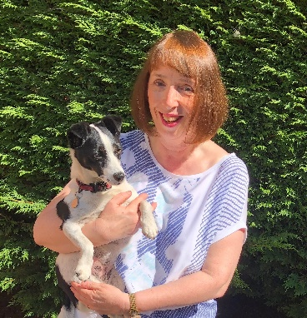
Fiona Coulter
I joined Rosie’s Trust in June 2017 as a Canine Support Volunteer after seeing an article in the paper about Bronagh O’Neill and the charity she had set up. Following various lockdowns, I decided that I wanted a new challenge but was very keen to stay involved with the charity so I joined the Board of Trustees in September 2021.

Since joining Rosie’s Trust as a volunteer, I have seen first-hand the importance of the work of the charity. Through our involvement, pets can remain with their owners at the darkest of times. Often their pets are the only company that the beneficiary has and it’s heart-warming to see the love they have for their pets and how much they value the help volunteers provide. Without Rosie’s Trust, many of our beneficiaries would have had to give up their beloved pets and would be totally on their own. Definitely enough reason to volunteer with Rosie’s Trust!
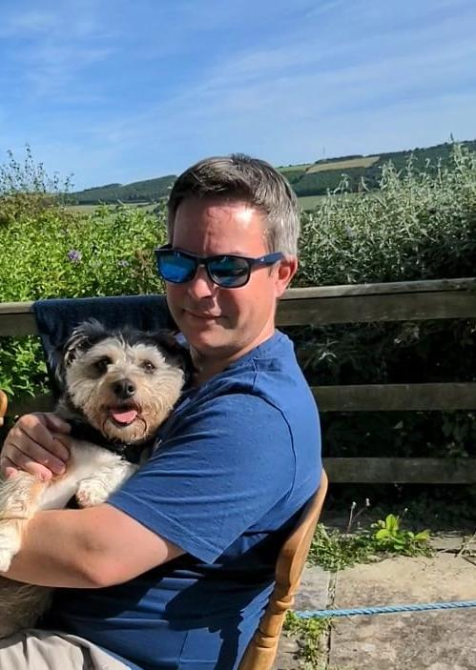
Tim Leonard
I have been a Trustee with Rosie’s Trust for the last seven years. It has been a joy to see the charity develop from the beginning, though the vision and efforts of Bronagh O’Neill to the current time under our wonderful operations team. It is great to see the impact of the charity in preserving the bond between our beneficiaries and their pets. I have found my time with Rosie’s Trust very rewarding and look forward to the growth of the charity over time to reach more people and pets in need.

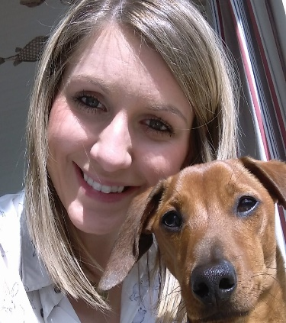
Joy McGimpsey
I have been a Trustee with Rosie’s Trust since September 2021. I got involved as I believe that what Rosie’s Trust do is unique, inspiring and extremely valuable to the community. I was drawn to the dual aspect of supporting vulnerable people as well as benefitting their pets. A pet is part of the family and to work with an organisation that recognises and champions pets while removing the stresses and anxieties of their owners at what can be difficult times is extremely rewarding.

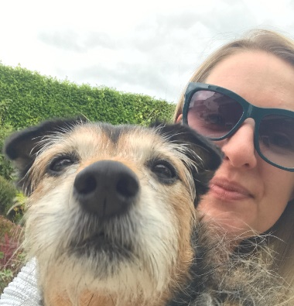
Emer Rice
I have been a Trustee since January 2021. As an animal lover I really wanted to get involved with Rosie’s Trust as I understand how important our pets are to us, never more so than when we are going through difficult times in life.
To play a small part in helping to maintain that bond between someone and their little companion is so rewarding.

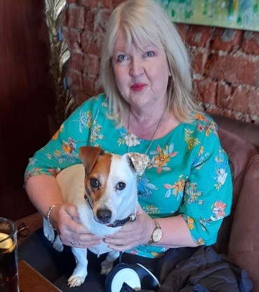
Joyce Savage
I joined the Board of Rosie’s Trust in September 2021. I have worked in the voluntary sector for more than 25 years in a range of charities of different sizes and levels of development. This has given me a good understanding of what works for a successful charity – and what doesn’t. Aside from charity management experience my expertise covers the areas of income generation, communications, campaigning and public affairs.

As a dog owner and someone living alone, I understand the concerns for a pet’s welfare when life isn’t going as it should or as was planned. I hope to bring my practical experience and personal motivation together to help Rosie’s Trust continue to grow and develop and to be there for all the 4- and 2-legged beneficiaries needing our support.
Note: We have four additional Trustees who will be completing their probationary period in May 2023. They are Jill Hawthorne, Louise Heatley, Clare Jess and Gayle Lavery.
All Trustee positions are voluntary at Rosie’s Trust. Typically, the term of office is for three years with the possibility of further extension.

ROSIE’S TRUST
ORGANISATION CHART

Board of Trustees
(Acting Chair: Josephine Mallon)
All volunteers

Marketing and Communications Lead ¹ (Claire Smyth – 21 hours per week)

Interim CEO
(Catriona Mac Arthur – 14 hours per week)

Community Engagement and Fundraising Lead ¹ (Phil Lucas – 21 hours per week)

Development Officer
(Laura Quinn – full-time)

Operations Manager
(Jayne McStay –
full-time)

Volunteer Support Officer
(Sandra McFadden –
full-time)

- Both positions - Marketing and Communications Lead and Community Engagement and Fundraising Lead – are funded for two years (to 2025) through the Dormant Accounts Fund, administered by the National Lottery Community Fund. Other positions are funded for three years (to 2026) by the National Lottery Community Fund (People and Communities grant programme).

Role and responsibilities of the Chair of the Board of Trustees
The Chair of Rosie’s Trust will provide strategic leadership to the Board of Trustees, ensuring that each Trustee fulfils their duties and responsibilities for the effective governance of the charity.
The Chair will also support the Chief Executive and ensure that the Board functions as a unit and works closely with the staff team to achieve agreed objectives. S/he will act as an ambassador and the public face of the charity in partnership with the Chief Executive.
Principal Responsibilities
Strategic leadership
• Provide leadership to Rosie’s Trust and our Board, ensuring that the charity delivers maximum positive impact for our beneficiaries.
• Ensure that Trustees fulfil their duties and responsibilities for the effective governance of Rosie’s Trust.
• Ensure that the Board operates within its charitable objects and provides a clear strategic direction for Rosie’s Trust.
• Ensure that the Board is able to regularly review major risks and associated opportunities, and satisfy itself that systems are in place to take advantage of opportunities, and manage and mitigate the risks.
• Ensure that the Board fulfils its duties to ensure the sound financial health of the charity, with systems in place to ensure financial accountability.
Governance
• Ensure that the governance arrangements are working in the most effective way for Rosie’s Trust.
• Develop the knowledge and capability of the Board of Trustees.
• Encourage positive change where appropriate, and address and resolve any conflicts within the Board.
• Appraise the performance of the Trustees and the Board on an annual basis.
• Ensure that the Board of Trustees is regularly refreshed and incorporates the right balance of skills, knowledge and experience needed to govern and lead the charity effectively.
• Work within any agreed policies adopted by the charity.
Efficiency and Effectiveness
• Chair meetings of the Board of Trustees effectively and efficiently, bringing impartiality and objectivity to the decision-making process.
• Ensure that Trustees are fully engaged and that decisions are taken in the best, long-term interests of Rosie’s Trust and that the Board takes collective ownership of these decisions.
• Foster, maintain and ensure that constructive relationships exist between the Trustees.
• Work closely with the Chief Executive to give direction to Board policy-making and to ensure that meetings are well planned, meaningful and reflect the responsibilities of Trustees.
• Ensure that decisions taken at meetings are implemented.
Relationship with the Chief Executive and the staff team
• Establish and build a strong, effective and a constructive working relationship with the Chief Executive, ensuring s/he is held to account for achieving agreed strategic objectives.
• Support the Chief Executive, whilst respecting the boundaries which exist between the two roles.
• Ensure regular contact with the Chief Executive, and develop and maintain an open and supportive relationship within which each can speak openly about concerns, worries and challenges.
• Liaise with the Chief Executive to maintain an overview of Rosie’s Trust affairs, providing support as required.
• Conduct an annual performance appraisal of the Chief Executive in consultation with other Trustees.

Note: The above list is indicative only.

Person specification
The Chair of Rosie’s Trust will have the following attributes:
- An animal lover who understands the strong bond that can exist between people and their companion pets.

- Experience of leadership of an organisation.
- Experience of chairing boards and committees, keeping meetings to time and ensuring everyone gets an opportunity to speak.

- A commitment to be well informed about the work of Rosie’s Trust and to devote the necessary time to the requirements of the role.

- Good communication and interpersonal skills.

- Impartiality, fairness and the ability to treat sensitive information confidentially.

- Good understanding of Rosie’s Trust’s work and the key stakeholders with whom we engage.

Application Process
If you would like to apply for the position of Chair of the Board of Trustees of Rosie’s Trust, please send your CV together with a cover letter outlining the reasons for your interest in the position and the skills and experience that you would bring to Rosie’s Trust.
Please send this documentation to catriona@rosiestrust.org by 5.00pm, Wednesday, 24 May, 2023.

